MINISTRY OF EDUCATION AND SCIENCE OF THE REPUBLIC OF KAZAKHSTAN

INTERNATIONAL INFORMATION TECHNOLOGY UNIVERSITY JSC

FCTC

DEPARTMENT OF COMPUTER ENGINEERING

**Pre diploma PRACTICE REPORT**

**Major 6B06108 –** Data Science and Machine Learning

«EvoTech Центральная Азия» Programmer-Developer

Done by: Beiseuova Anel ______________

«___ » ______2022 (signature)

Head of practice: Chinibayeva TT. _________________

«___ » ______2022 (signature/assignment)

Almaty 2023

CONTENT

List of terms and abbreviations

INTRODUCTION  
1. Front-End of the project

2. Back-End of the project

3. deepASR for human understanding

4. NLU - Conversational Studio

CONCLUSION

LIST OF TERMS AND ABBREVIATIONS

1. OS-Operating System

2. LLP- Limited Liability Partnership.

3. PC- Personal Computer

4. DBMS- Database Management System

5. IT-Informational technology

6. NLU - Natural Language Understanding

**INTRODUCTION**

The professional internship took place in LLP "Evotech Центральная Азия" from 02/01/2023 to 04/02/2023 at the address in Almaty, 38 Zhanar st. In a professional internship, my position was an programmer-developer. From the organization, my supervisor was the head of the IT department Torchik Vladimir. The company LLP "Evotech Центральная Азия" development of complex systems and services for large business.

**1. Front-End of the project**

During practice, we wrote the front in the extensible markup language xml. We used config files to implement the butt and associated this butt with the front and back. (Picture 1). Each config stored data. For example, audio was stored in the audio config, and inside the app config, the logic of the voice robot was developed. app config had targets, actions, trackers and more. Each target stored an action group. (Picture 2). Trackers worked at some kind of event. In addition to these fields, we also had messages and confirmations. To communicate with the backend, we called the backendcall field and passed values there, and returned on the way.

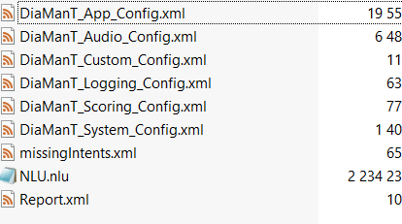

Picture 1.

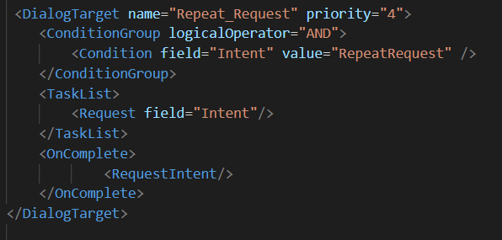

Picture 2.

**2. Back-End of the project**

We wrote the backend of the project in Java and compiled the project through maven. The main logic took place in a custom module class and further developed depending on the project. (Picture 3).

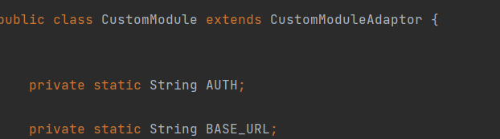

Picture 3.

to return to the butt, we sent the values in map format. (Picture 4).

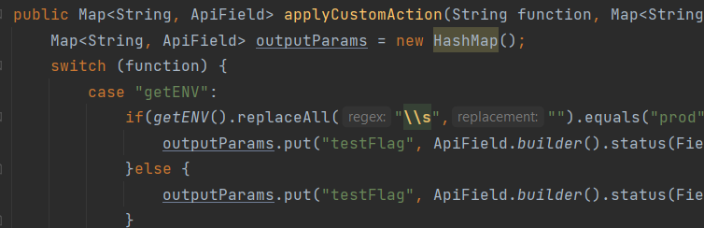

Picture 4.

**3. deepASR for human understanding**

To recognize a person's conversation, we did a compilation on the server using a ready-made model. If the recognition was small, they would add it manually, thereby retraining the model. There were several types of finished models depending on the field. and which we will use, we agreed directly through the project manager. (Picture 5).

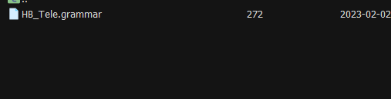

Picture 5.

**4. NLU - Conversational Studio**

Further, we will have to work out the recognized word, and in this step we are helped by nlu. with the help of the program, we connect individual words and make phrases, that is, intents. and we send these phrases as one final value, which our butt will process and use for further work. (Picture 6).

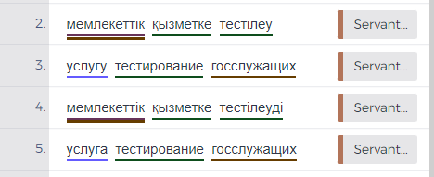

Picture 6.

**CONCLUSION**

During my practice, I gained a lot of experience in the field of IT. I discovered new qualities such as: Sociability and punctuality. And she persisted in developing responsibility and perseverance. In addition to personal qualities, I gained practical knowledge such as experience with xml, JAVA and NLU. This internship is a wonderful practical experience for my future profession. During the internship, I got acquainted with new facts and once again made sure that I was not mistaken when choosing a profession. I updated my theoretical knowledge and learned more about my future field of work.